********************************* Press Release ***************************************

June 20, 2016
Lake George Marathon Swim
Robert Singer
518-791-1295

Local Swimmer Sets Record for Length of Lake George

David Dammerman, 47 years old, of Saratoga Springs, swam the 32.2 miles of Lake George in 18 hours, 54 minutes, and 22 seconds on June 18-19. This shattered the record of 21 hours and 26 minutes set by John Freihofer in 1981. He started at 5 PM on Saturday and finished at 11:54 AM on Sunday. The most recent successful non-stop swim of Lake George was by Lake Desolation resident Jerry Ferris in 1983. Dammerman joins Ferris in saying it was the hardest swim he’s ever done, and that comes following successful swims across the English Channel. Dammerman also holds the record for the fastest swim across the 25 miles of Lake Memphremegog, VT. Dammerman was one of two swimmers who started the swim. The second swimmer, a very experienced marathon swimmer from New York City, dropped out after 13 hours and 14 hours when it was apparent that she would not finish in under 24 hours.

The water temperature averaged 68 degrees. The weather was warm, with 80’s at the start, falling to 56 in the early morning, and rising to the mid-80s at the finish. Winds were mostly light but several hours early Sunday morning included winds of 10-15 MPH out of the south, resulting in moderate chop.

Dammerman is a Saratoga businessman who swims for fun, health, and the social contacts with similar-minded people. He has been an active advocate for many local swims and triathlons, and was the Race Director of the two-mile USMS National championship Betsy Owens cable swim in Lake Placid. His training involved swimming 5-6 days a week at the Saratoga YMCA for about 4,000-8,000 yards a day, and in open water whenever he traveled. He started training in Lake George this year in April, when the water was 49 degrees. Despite this experience, he said “I almost quit when I cleared the Narrows and Dome Island seemed to not get closer for hours.” Then he almost quit again when Canoe Island remained on his horizon, seemingly immobile. His support crew included Deb Roberts (Queensbury), Anne Green (Bolton Landing), Chirs Bowcutt (Burnt Hills), and Roy Ketring (South Glens Falls).

Dammerman and his crew along with Race Director Robert Singer (Queensbury) and Co-Director Alex Meyer (2008 Olympic 10K swimmer and 15K world champion, Ithaca NY) are all planning the Lake George Marathon Swim, September 17-18, 2016. The purpose of the swim this past weekend was to test the logistics and support for the big September Event, which will have 14 solo swimmers and 75 relay swimmers in 14 relay teams. The Lake George Marathon Swim is celebrating the beauty of Lake George, the sport of marathon swimming, and paying homage to the past. In September, the swimmers, with their flotilla of 28 kayaks and 33 support boats will follow in the bubbles of other Lake George champions, starting with the first person to ever swim the entire Lake, Diane Struble, who started in Ticonderoga at what is now known as “Diane‘s Rock” and finished at the Village docks in Lake George 35 hours and 30 minutes later.

Swimmers expect to raise $14,000 for charities, including $7,000 for local Lake George charities. The September swim is being made possible by generous support from the Village of Lake George, Snug Harbor Marina, Shoreline Cruises, Adirondack Cardiology, and Roberts Environmental Consulting.

Past crossings of Lake George (courtesy Gwenne Rippon).

Date | Swimmer | Age | Time
1958 | Diane Struble | 25 | 35:30:00
1962 | Bill Stevens | 31 | 31:27:00
1967 | George Dempsey | 17 | 32:15:00
1977 | Stella Taylor | 45 | 26:51:00
1981 | John Freihofer | Unknown | 21:26:00
1983 | Jerry Ferris | 43 | 29:15:00
2016 | David Dammerman | 47 | 18:54.22

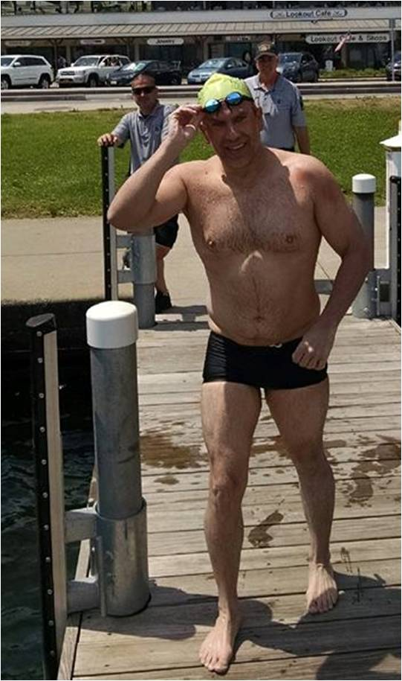
David Dammerman after swimming 32.2-mile Lake George, June 19, 2016 (photo courtesy George Stark).

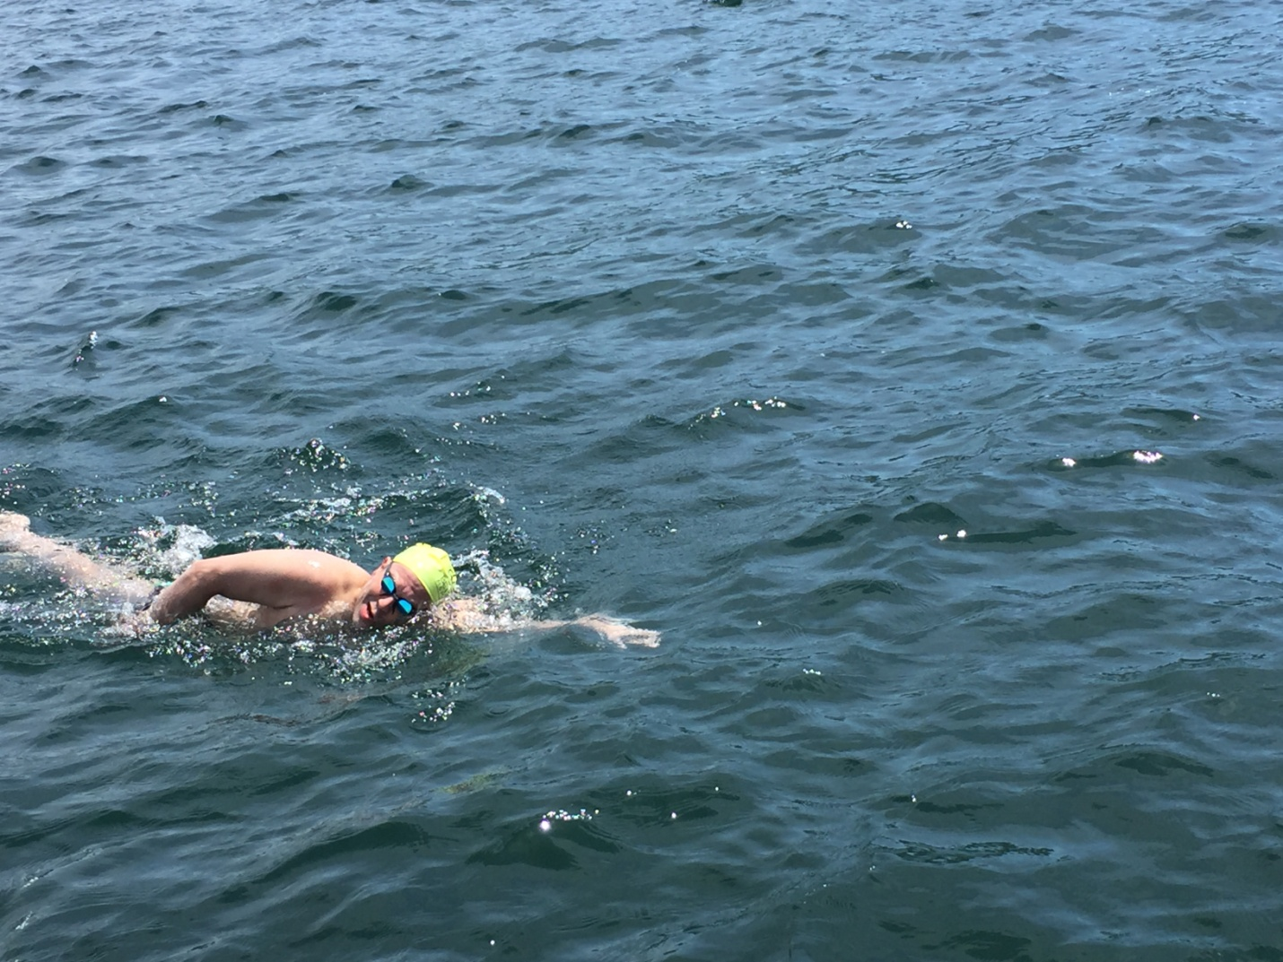
David Dammerman crossing finish line after 32.2 mile Lake George Swim, June 19, 2016 (photo courtesy Bob Singer)
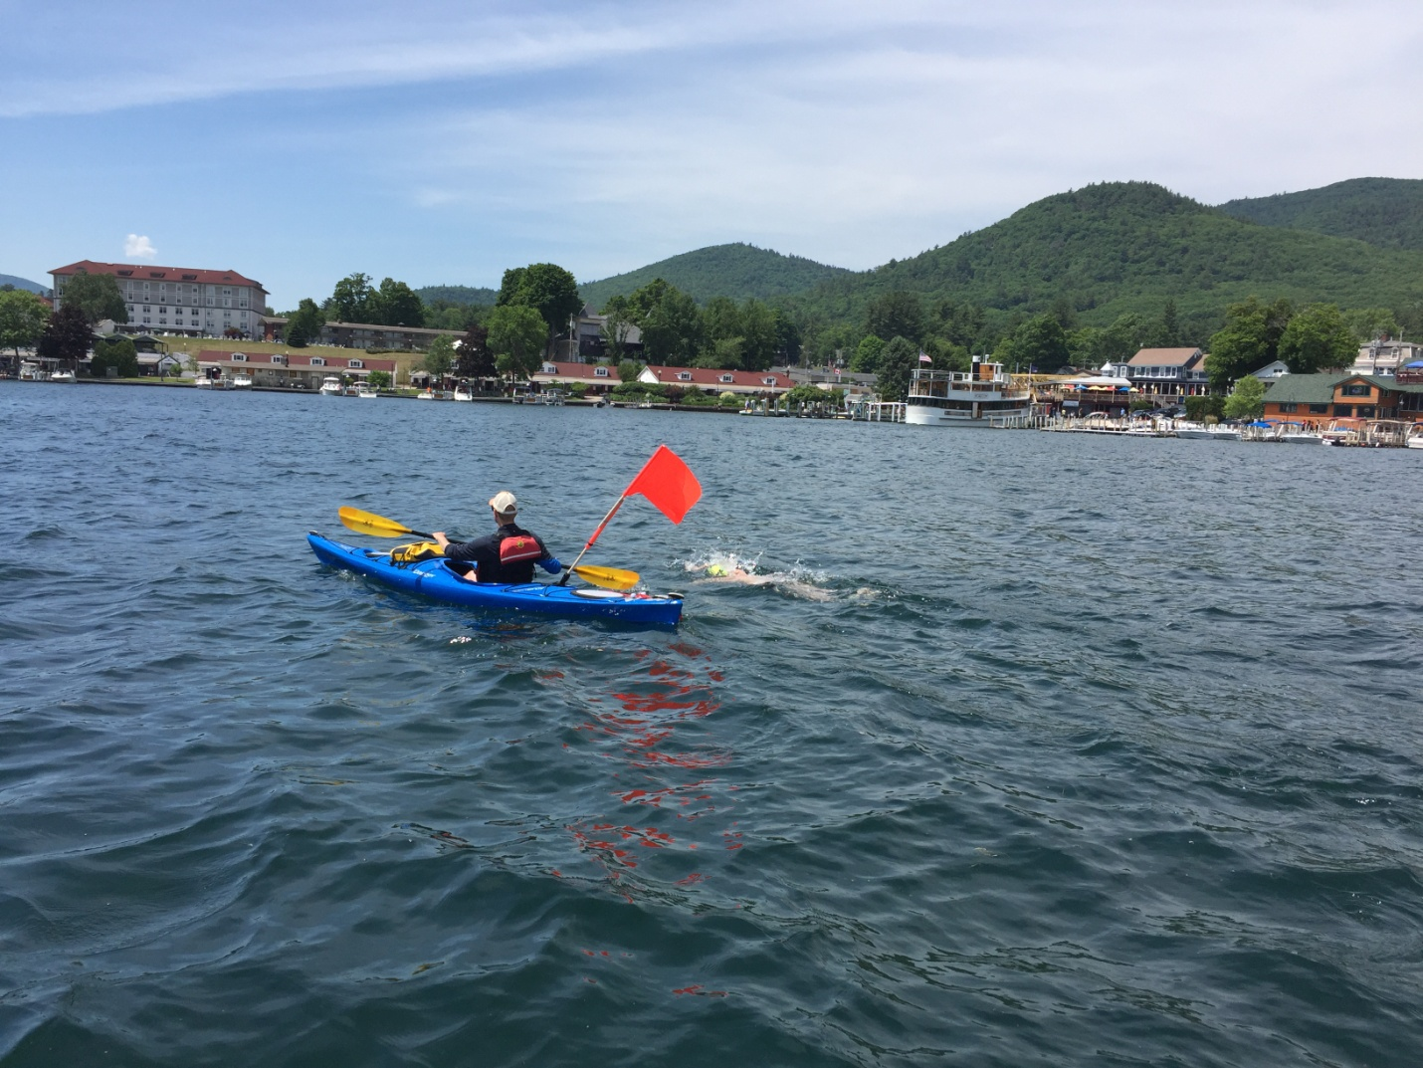
David Dammerman nearing the finish of the 32.2 miles of Lake George, June 19, 2016. Kayaker is Chris Bowcutt (photo courtesy Deb Roberts).
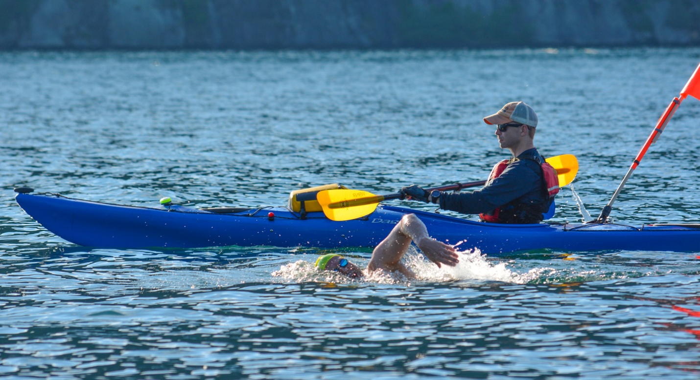David Dammerman and kayaker Chris Bowcutt in the northern basin of Lake George, June 18, 2016 (photo courtesy Richard Timberlake).

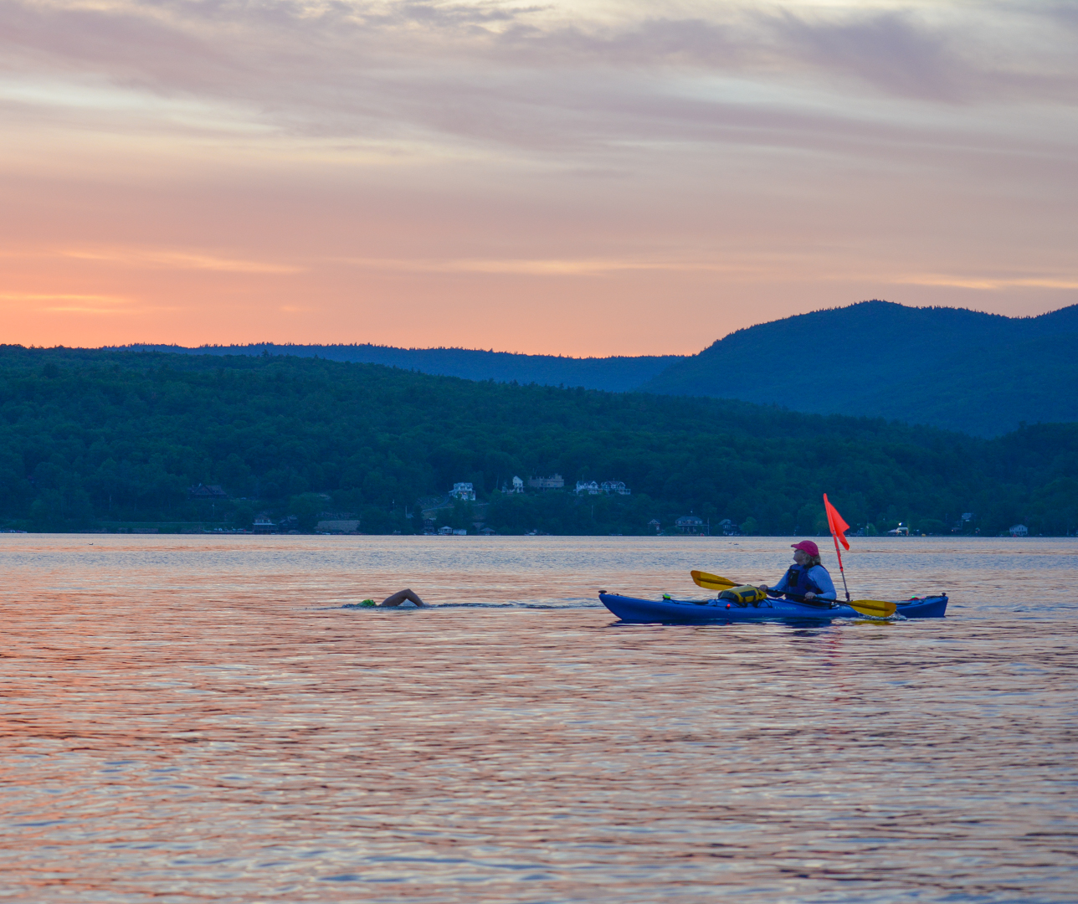
David Dammerman and kayaker Anne Green north of Sabath Day Point, Lake George, June 18, 2016 (photo courtesy Richard Timberlake).

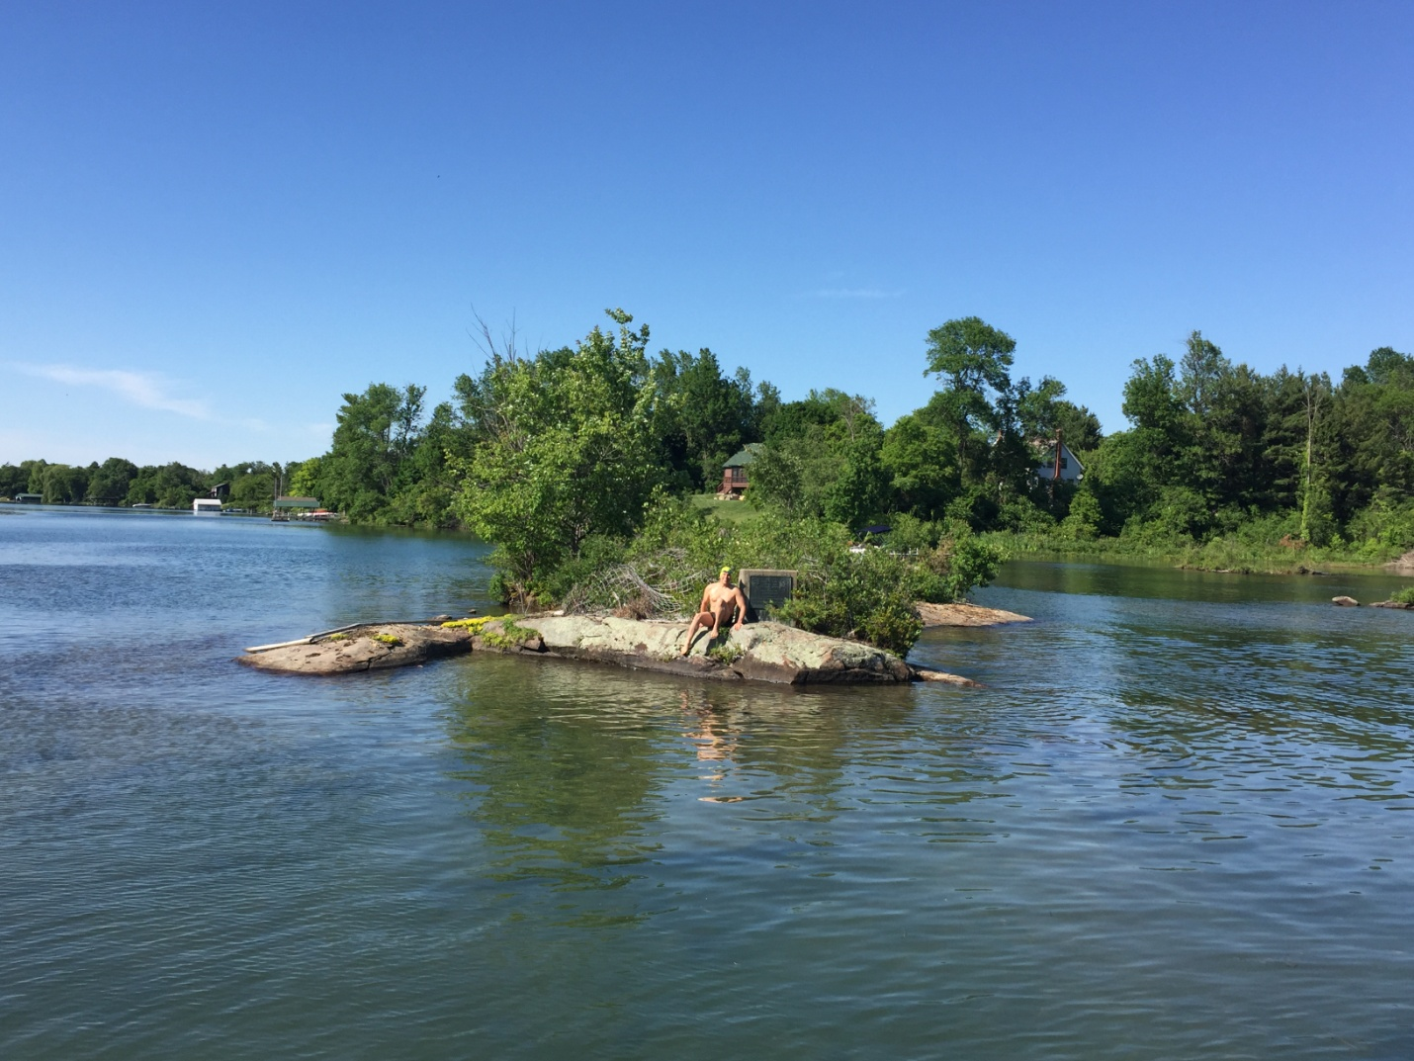
David Dammerman before the start of the Lake George Marathon, on “Diane’s Rock.” The brass plaque commemorating Diane Struble’s 1958 swim is visible over his left shoulder (photo courtesy Deb Roberts).

